Module 1 Study Guide Mrs. Jennings

1. In order to obtain a learner’s permit in Virginia you must be at least 15 years & 6 months old.

2. The minimum age for a licensed driver accompanying a driver with a
learner’s permit is 21years of age or 18 (if immediate family member)

3. An applicant for a learner’s permit must score 100% on the signs test.

4. Persons less than 19 must hold a learner’s permit for a minimum of 9 months before a temporary license can be issued.

5. Persons with a learner’s permit cannot drive between midnight and 4 am

6. The type of license which will allow a person to drive a large truck or a van
designed for 16 or more passengers is a CDL.

7. A driver with a learner’s permit is limited to 1 passenger under the age of 18.

8. The penalty for anyone less than 20 who is convicted of his/ her 1st demerit violation is a mandatory driver improvement class.

9. A driver’s license expires on the licensee’s birthday in ages divisible by 5

10. If you are less than 18, you will receive your permanent license from
Juvenile and Domestic Relations Court.

11. If you drive on the public roads of Virginia, you must submit to an alcohol or drug test when requested. This is known as the Imolied Consent Law.

12. Under the Zero Tolerance Law, drivers less than 21 may lose their driving privilege if they have a BAC of .02 or above.

13. Vehicles registered in Virginia must be inspected once a year.

14. The minimum amount of liability insurance required to satisfy the financial
responsibility law in Virginia is 25,000/50,000/20,000.

15. Your decision to become an organ donor should be recorded on your driver’s license and discussed with your family.

16. There is a national network to coordinate organ distribution.

17. In Virginia, you must have a special license to drive a motorcycle.
18. The uninsured motorist fee allows you to drive an uninsured vehicle

19. You are covered by your parents’ insurance policy when you have a
learner’s permit.

20. In this situation, no one
who has the right of way. B

A
Uncontrolled Intersection

A

21. In this situation, car B must
yield.

B
Car B is turning left

22. In this situation car B must
yield.

A B

23. When you approach a school bus with flashing red lights from either
direction, you may proceed only if there is a median between you and the bus.

24. When an emergency vehicle approaches you using its siren, you should
pull over to allow a clear path for the emergency vehicle

25. It takes a train going 50 mph approximately 1 mile ½ to stop safely.

26. The crossbuck is considered the same as a yield sign.
27. A train’s speed is easy to judge and will appear slower than it is.

28. Most railroad crossing crashes are the result of driver error.

29. A red light indicates stop and remain stopped

30. A flashing amber light indicates you should proceed with caution

31. A green arrow indicates a protected turn lane – go in the direction of the arrow

32. Orange signs indicate construction.

33. School crossing signs are fluorescent optic yellow

34. The shape of this sign indicates

warning

35. The shape of this sign indicates

rail road crossing

36. The shape of this sign indicates

regulatory

37. This sign indicates
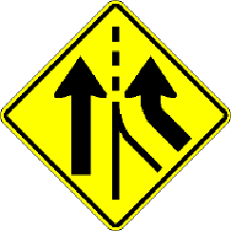 added lane

38. This sign indicates
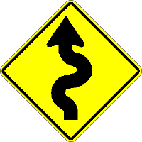
curvy road ahead

39. A yellow line (solid or broken) indicates

two way traffic
40. A solid line indicates no passing.

41. A broken white line indicates pass with caution and one way traffic.

42. This road marking indicates
HOV lane and restricted lane (bus or bicycles)

43. This lane is reserved for
vehicles from both directions turning left

44. The basic color for construction signs is orange
45. You should signal at least 4 seconds before you turn or change position.
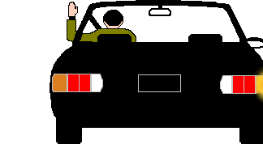
46. This hand signal indicates a right turn.

47. The correct method of steering through a turn is push/pull/slide.
48. When parking downhill with a curb, turn the wheels toward the curb.
49. You must park at least 500 feet from a fire truck answering a call.
50. The speed limit in school, business and residential areas is 25 mph.
51. You are required to dim your headlights when you are within 500 feet of an approaching vehicle.
52. Important points to remember in skid control is look and steer in the direction you want to go and do not break.
53. If your tire loses pressure while you are driving, you should keep a firm grip on the steering wheel with both hands and release the accelerator pedal slowly.
54. Passing on the right is legal in Virginia under certain circunstances.
55. If the foot brake fails, the parking brake may be used to stop the vehicle a
and pumping the brake may help restore some brake pressure.
56. The use of a lower gear may be helpful when going up or down steep grades.
57. The use of cruise control is not to be used on slippery roadways.

